Contents

I. Introduction 1

II. Getting started 1

1. Requirements 1

2. Installation 1

III. Screen flow and work flow diagram 2

1. Screen flow 2

2. Workflow 3

IV. Features 5

1. Fetch user chat rooms: 5

2. Fetch random users: 6

3. Create chat room: 7

4. Search by username: 8

5. Fetch message by chat room: 9

6. Chat: 10

7. Upload image: 12

V. Conclusion 14

# Introduction

The **Chat-Socket Application** is a real-time messaging app that makes it easy for users to chat with each other. It allows users to send and receive messages instantly, manage multiple chat rooms, and add friends to chat with.

The frontend is built with **React** and **Redux Toolkit**, and **Vite**, making the app fast and easy to use, while the backend uses **Spring Boot** and **WebSocket** to handle real-time messaging. The app also supports emojis, image sharing through **Firebase**, and saves message history in a database.

This guide will help you set up and run both the frontend and backend of the app.

# Getting started

## Requirements

To run the **Chat-Socket Application**, ensure that the following software and tools are installed:

**Frontend Requirements:**

* **Node.js**: Version 20.17.0 or higher. You can download it from [**Node.js official website**](https://nodejs.org/) or manage versions using **NVM** (Node Version Manager).
* **npm**: Installed with Node.js (for managing packages and running the development server).
* **Visual Studio Code** or any code editor of your choice.

**Backend Requirements:**

* **JDK 17**: The Java Development Kit version 17 is required to run the Spring Boot backend. You can download it from [**Oracle’s official website**](https://www.oracle.com/java/technologies/javase/jdk17-archive-downloads.html)**.**
* **Maven**: For building and running the Spring Boot project. If you don’t have it installed, you can download it from [**Apache Maven**](https://maven.apache.org/download.cgi)**.**
* **IDE**: IntelliJ IDEA (recommended) or any other Java IDE for running and managing the backend project.

Once you have the required tools installed, you can proceed with the steps to set up the frontend and backend environments.

## Installation

For detailed installation steps, please [**check my README**.](https://github.com/ThienAn321/chat-socket/blob/main/README.md)

# Screen flow and work flow diagram

## Screen flow

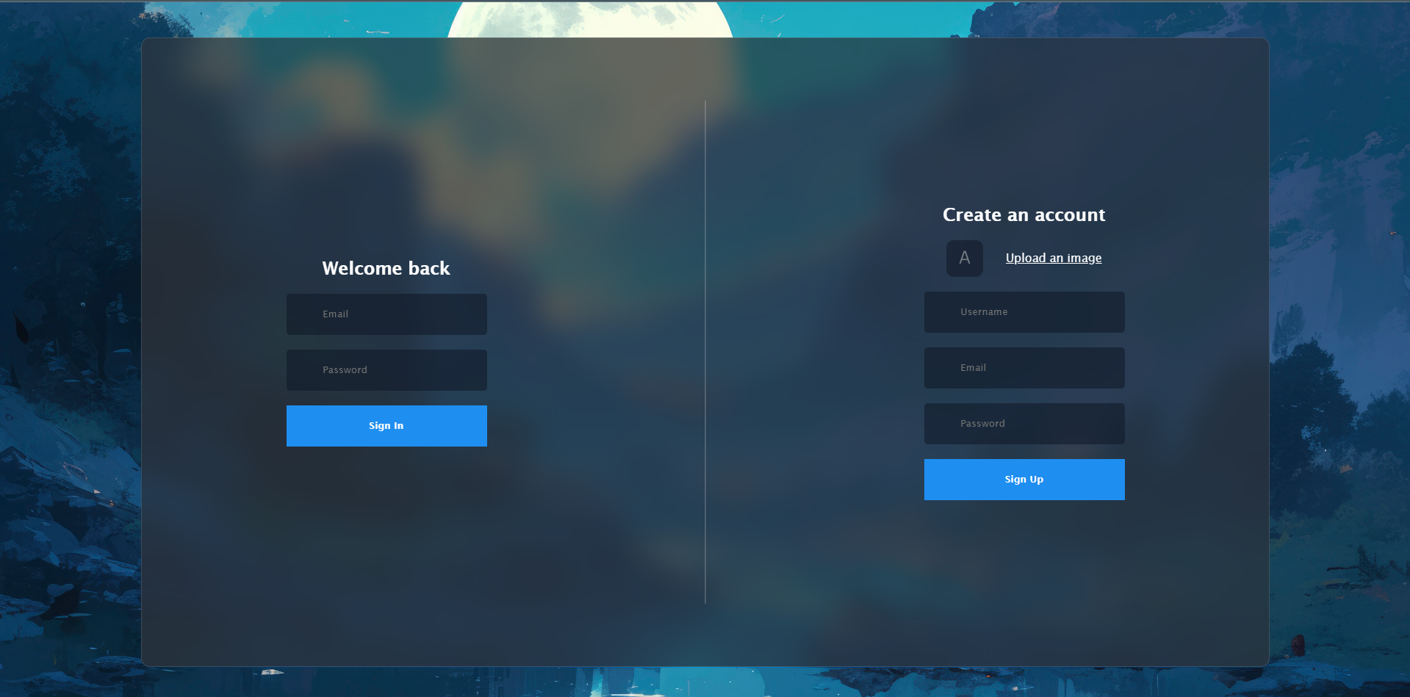

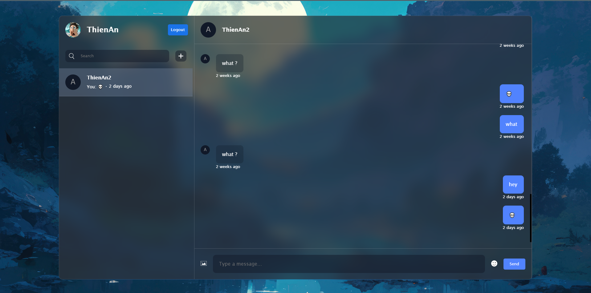

## Workflow

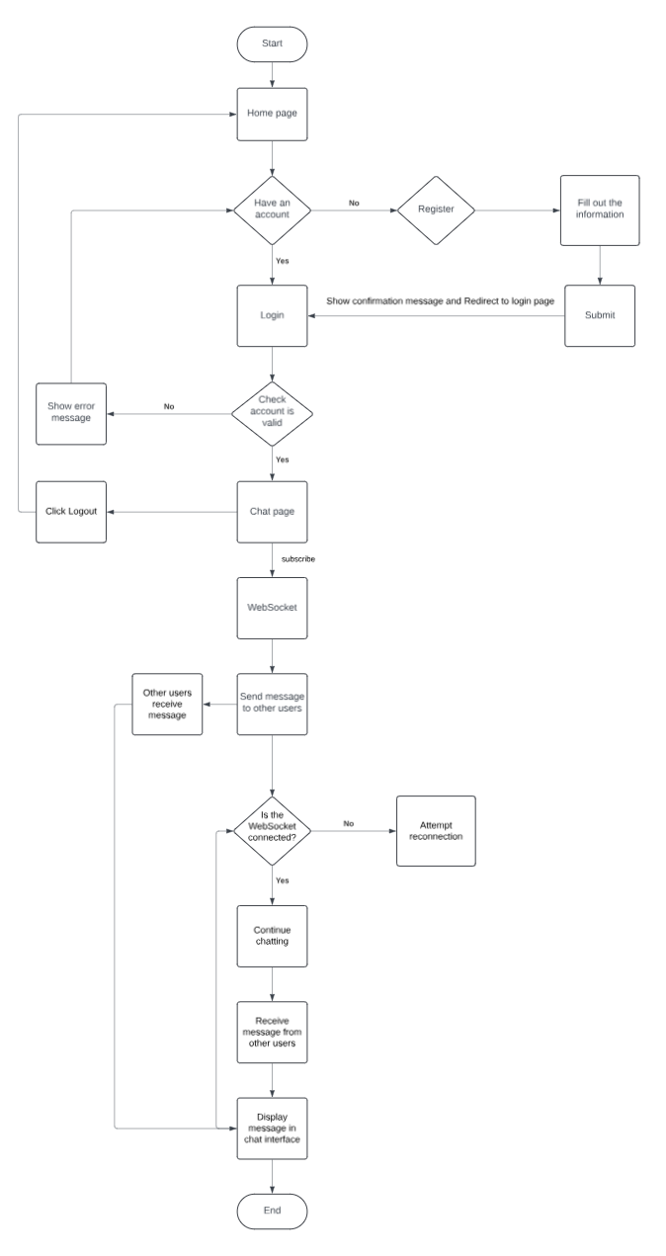

# Features

## Fetch user chat rooms:

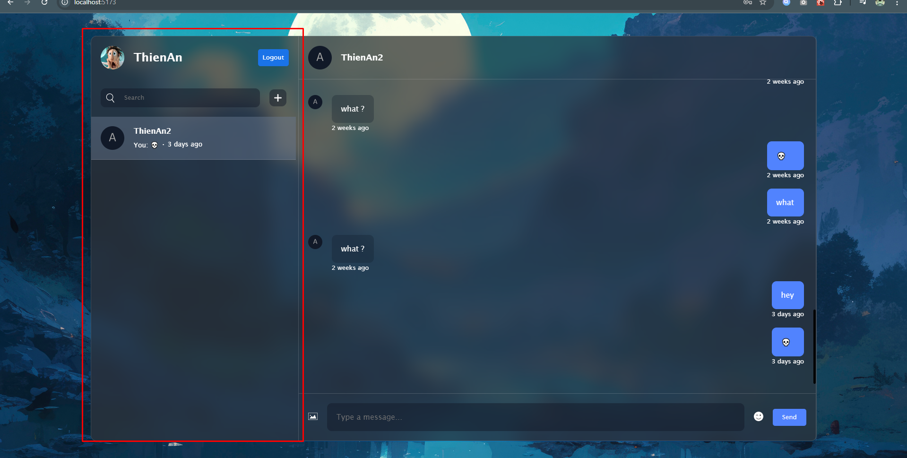

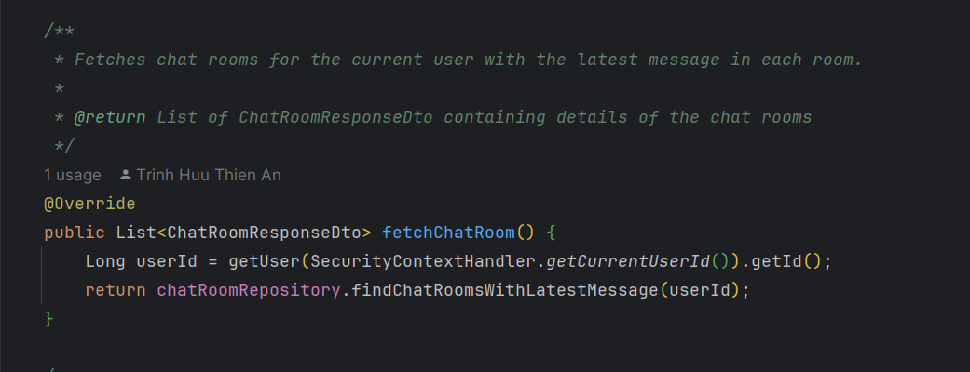

## Fetch random users:

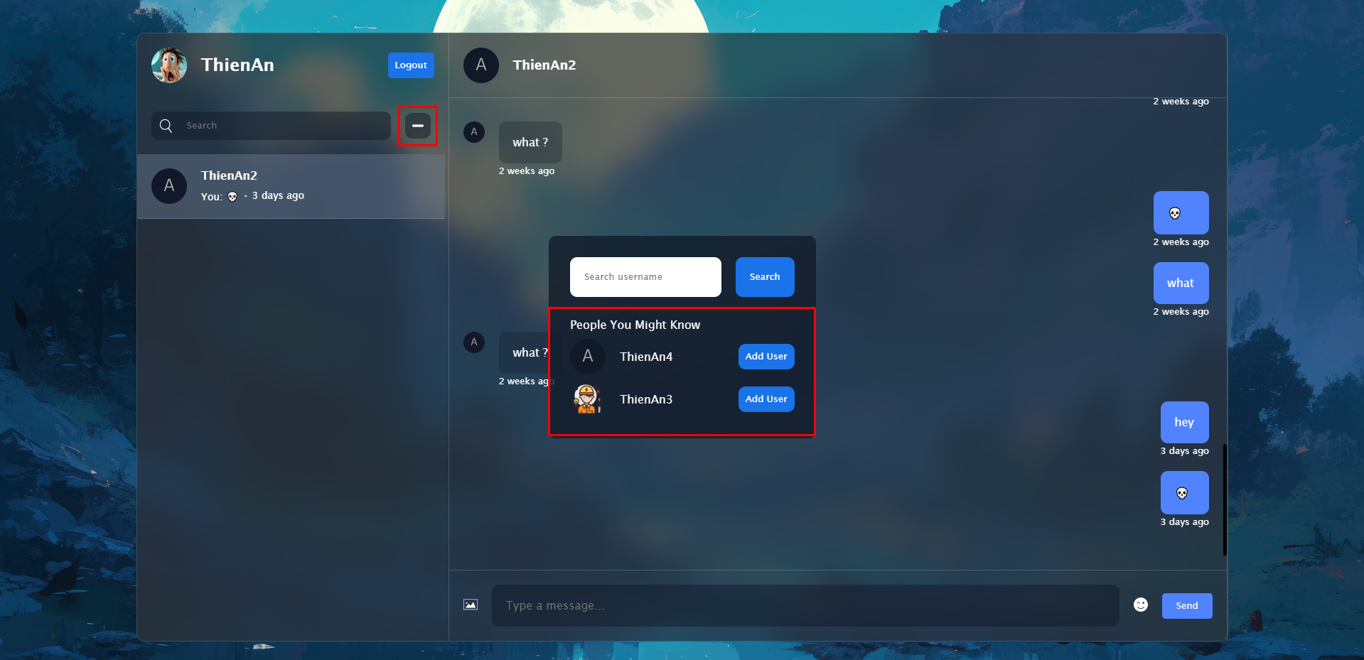

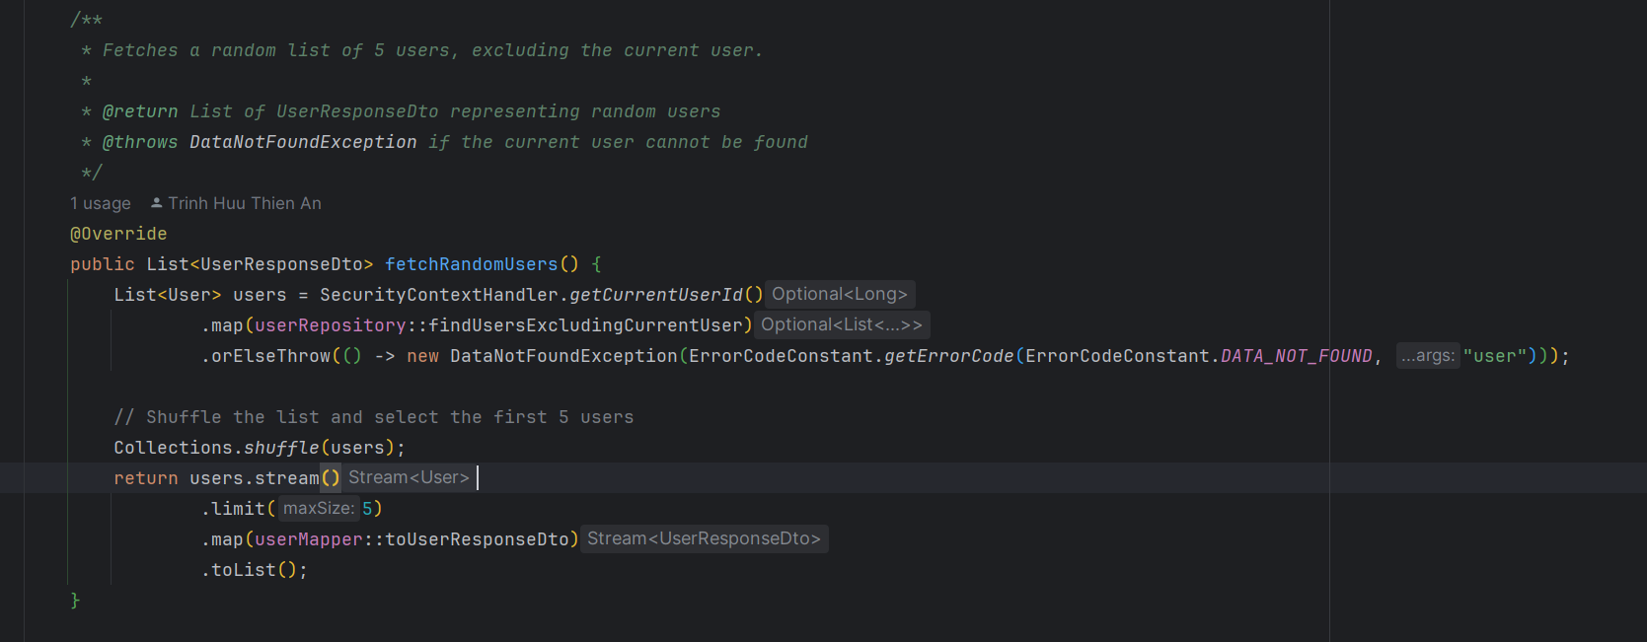

## Create chat room:

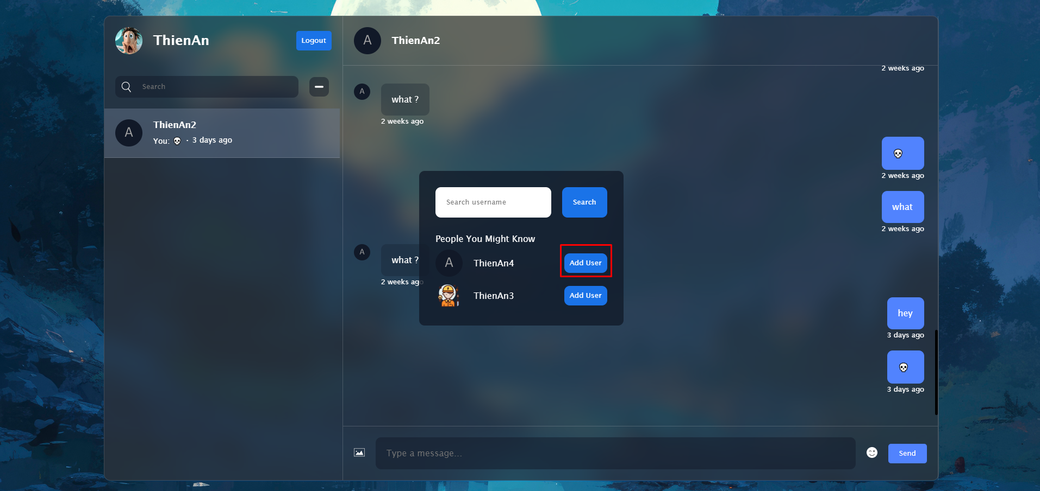

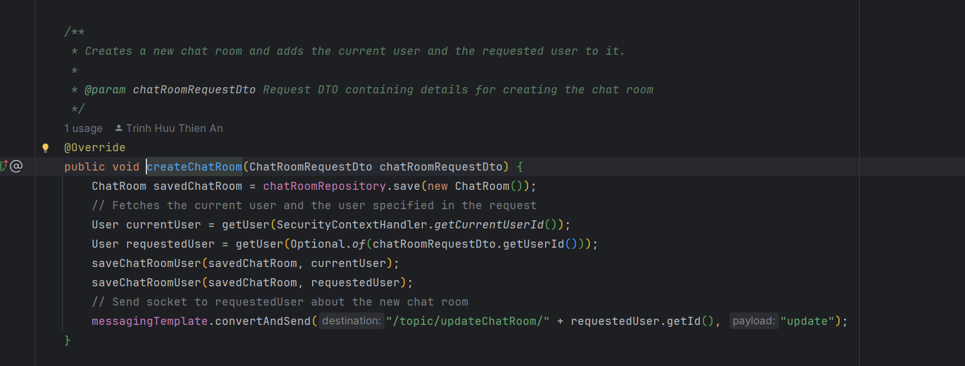

## Search by username:

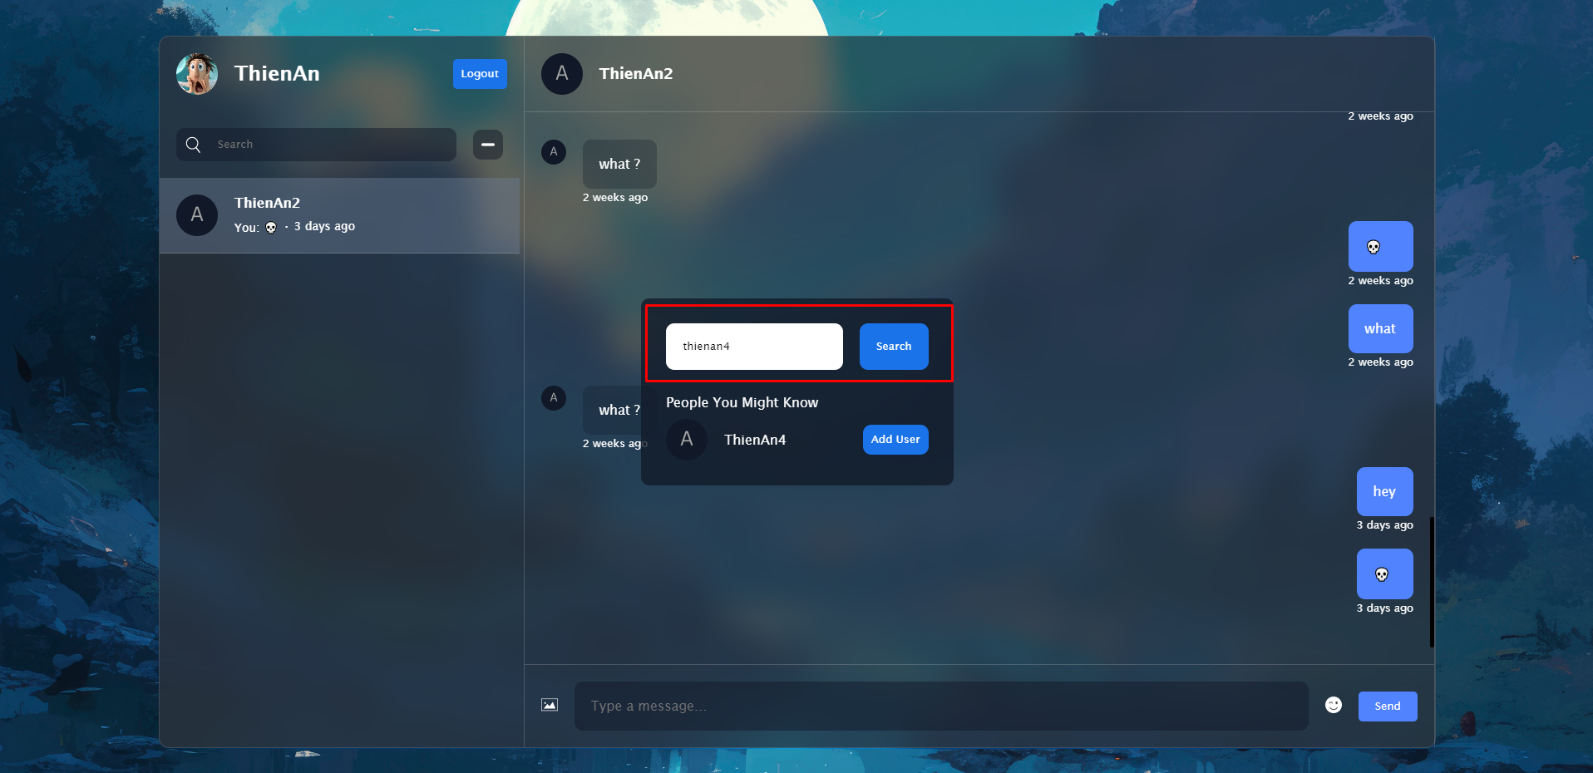

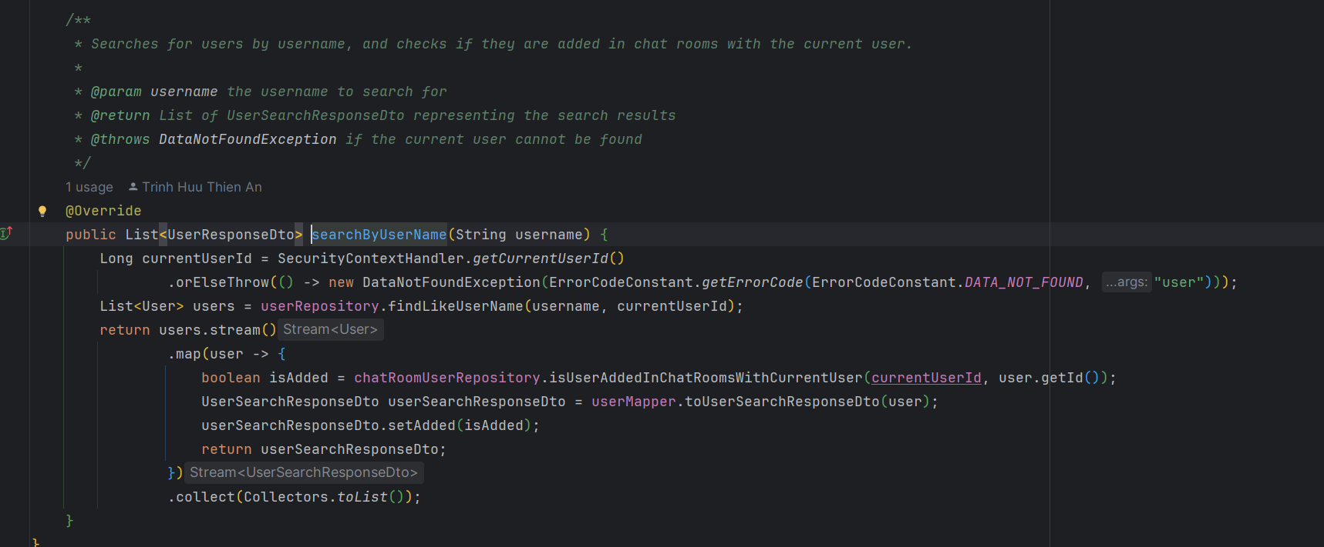

## Fetch message by chat room:

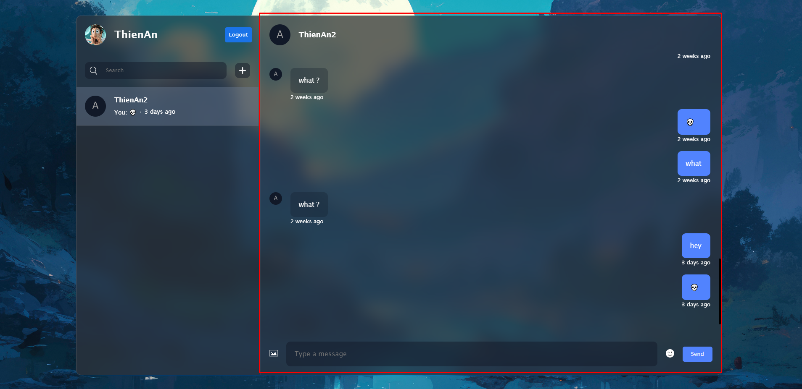

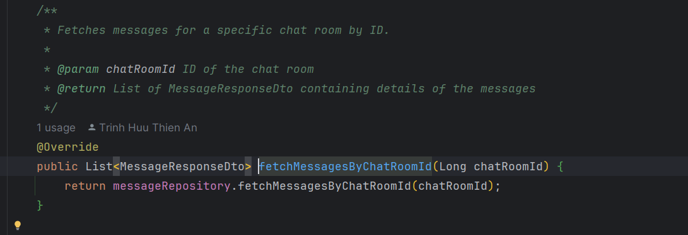

## Chat:

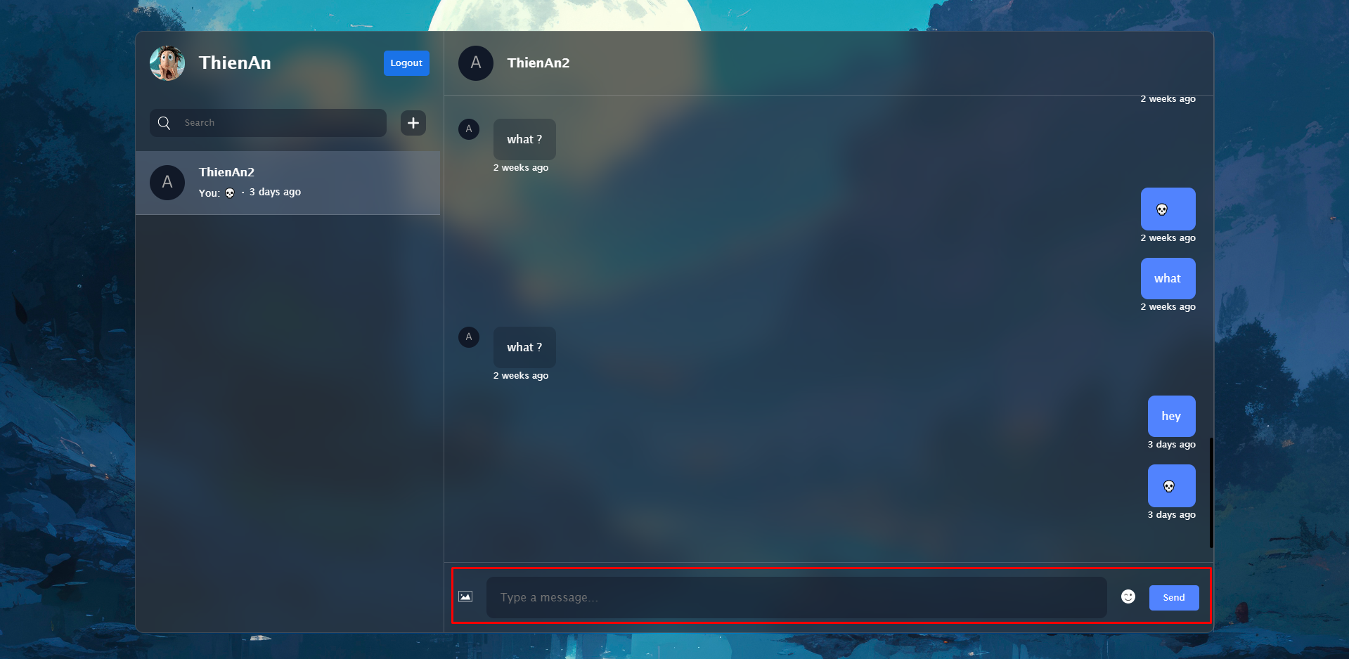

* + First, you need to configure the WebSocket message broker in your Spring Boot application.

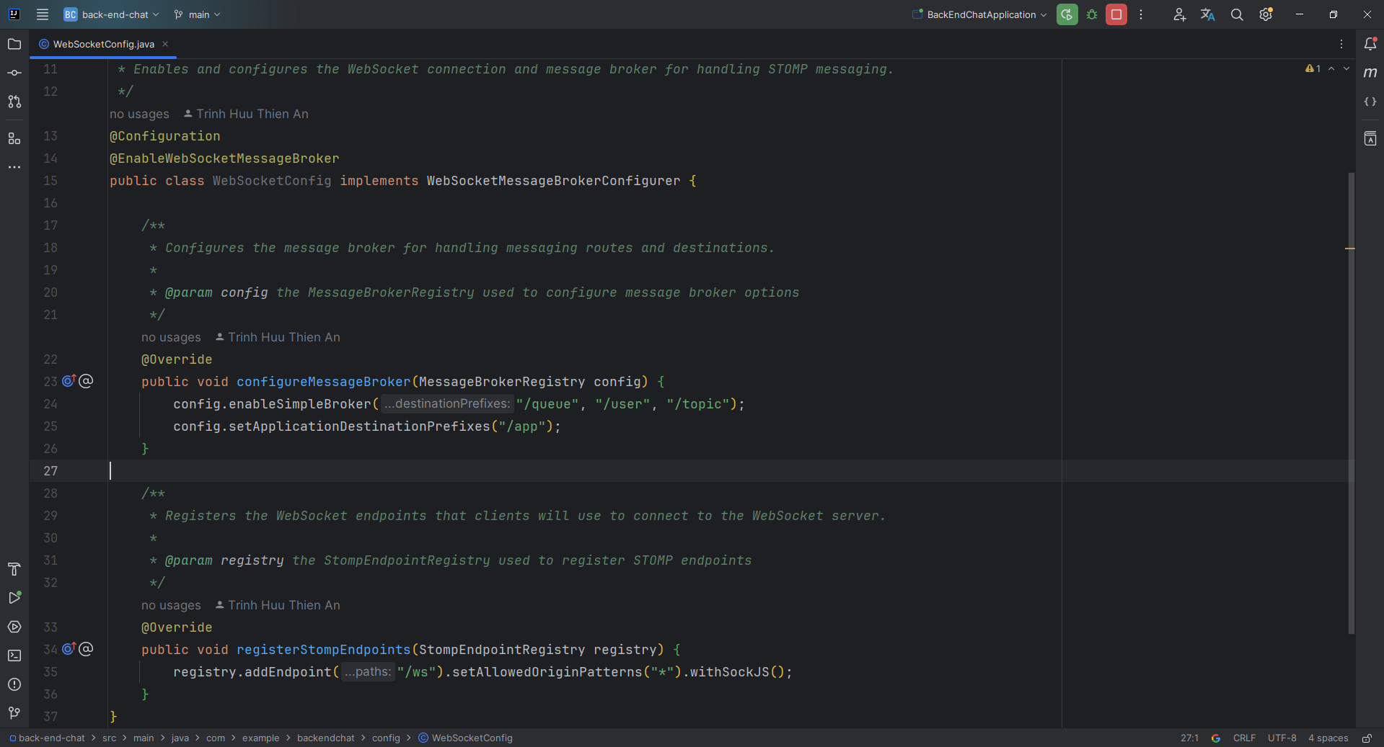

* + Second, you need to create ChatController.

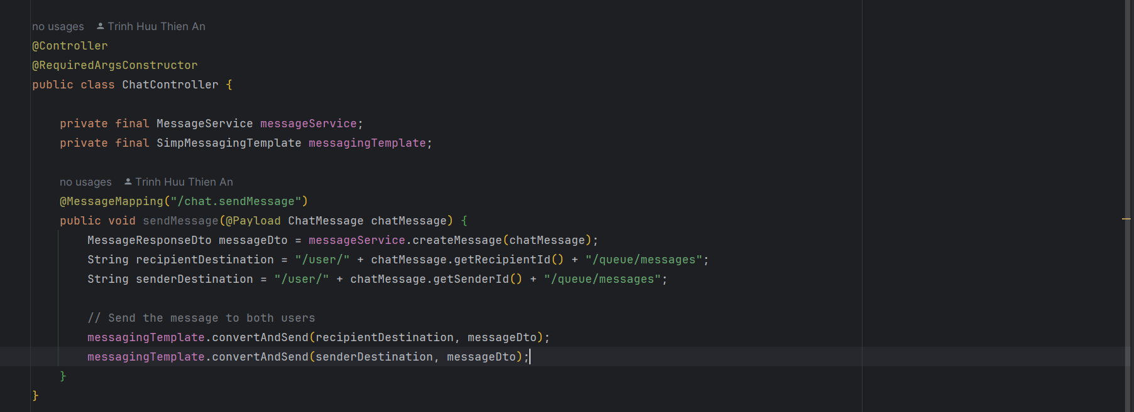

* + - **SimpMessagingTemplate**: Template for sending messages to WebSocket clients.
    - **@MessageMapping("/chat.sendMessage")**: Listens for messages sent to this specific endpoint.
    - **@Payload**: Binds the incoming WebSocket message to the ChatMessage object.



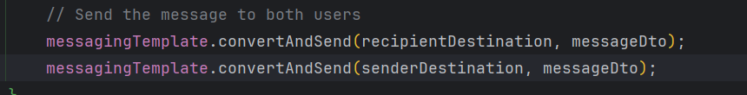

* + - Constructs destinations for sending messages to both the recipient and the sender.
    - Sends the message to both users using SimpMessagingTemplate.

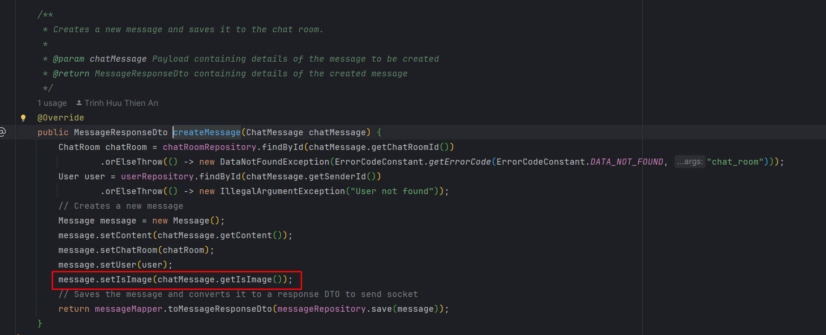

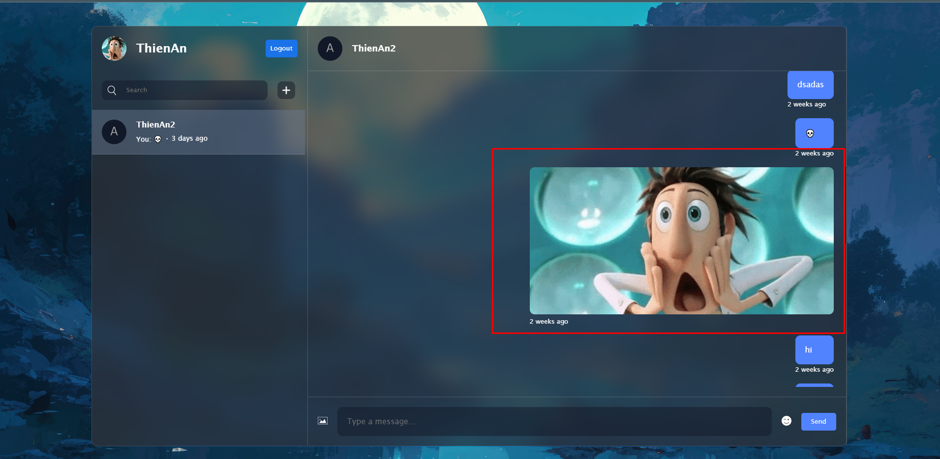

* + - **Image Flag**: The setIsImage method stores a flag indicating whether the message contains an image. This flag helps in displaying the message correctly in the chat interface.

## Upload image:

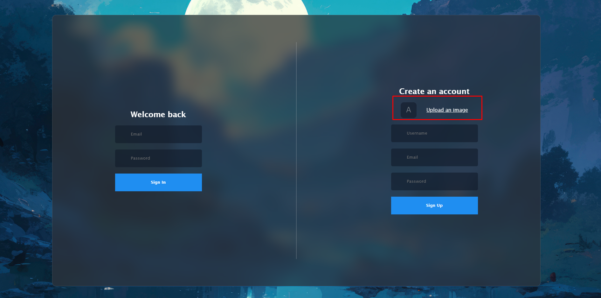

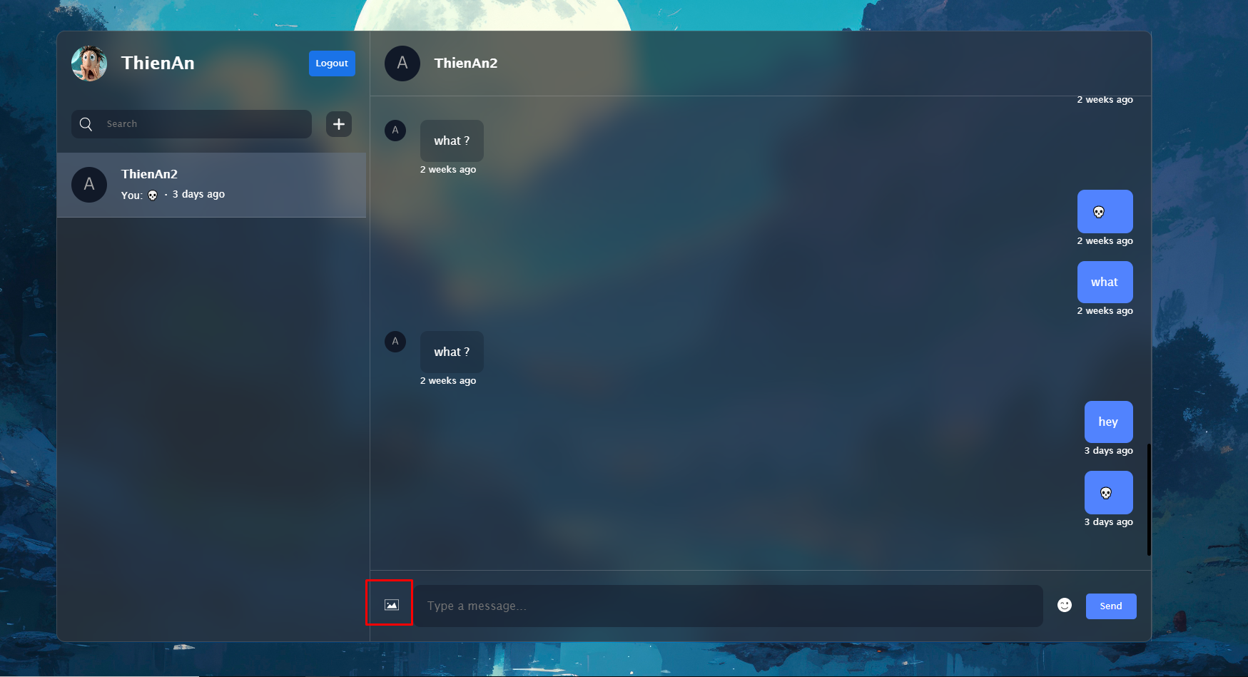

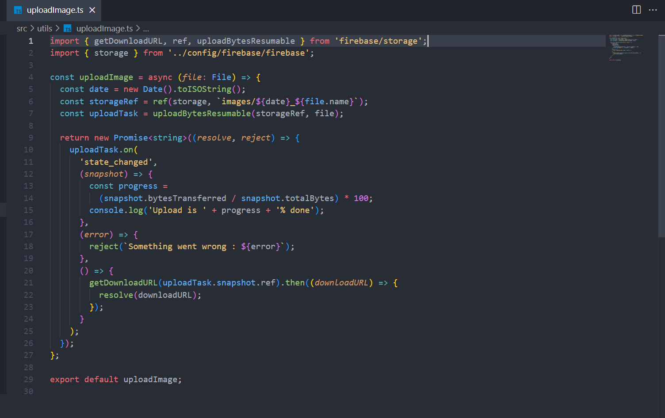

* + The uploadImage function uploads an image file to Firebase Storage, retrieves its download URL, and stores that URL in the database.
  + Steps:
* **Generate a Unique Filename**:
  + The function creates a timestamped filename using the current date and the original file name.
* **Create a Storage Reference**:
  + A reference to the location in Firebase Storage where the file will be stored is created.
* **Start Uploading**:
  + The file is uploaded using uploadBytesResumable, which allows monitoring of the upload progress.
* **Return a Promise**:
  + The function returns a Promise that resolves with the download URL of the uploaded image.
  + **Progress Tracking**: Logs the upload progress as a percentage.
  + **Error Handling**: Rejects the Promise if there’s an error during upload.
  + **Completion**: Once the upload is complete, it retrieves the download URL of the uploaded image.

# Conclusion

* The Chat-Socket Application provides a seamless real-time messaging experience for users, combining modern frontend technologies with a robust backend framework. With features like instant messaging, chat room management, image sharing, and emoji support, the application enhances user interaction and engagement.
* This guide has outlined the necessary requirements, installation steps, and key features of the application, ensuring that you can easily set up and run both the frontend and backend. Whether you are looking to engage with friends, manage conversations, or share media, the Chat-Socket Application offers a comprehensive solution tailored to meet your messaging needs.
* We encourage you to explore the features and capabilities of the application, contribute to its development, and leverage it as a base for building your own real-time chat applications.